Key Cloak Setup

Spring Boot 3.1.4

Reference ::

<https://www.keycloak.org/downloads>

<https://www.keycloak.org/getting-started/getting-started-zip>

<https://www.keycloak.org/docs/latest/securing_apps/#_spring_boot_adapter>

KeyCloak Download : <https://www.keycloak.org/downloads>

Add Database to Key Cloak

Open keycloak-22.0.4\conf\keycloak.conf

Enter DB Details (Ex: Postgresql)

Also added http-port=8081

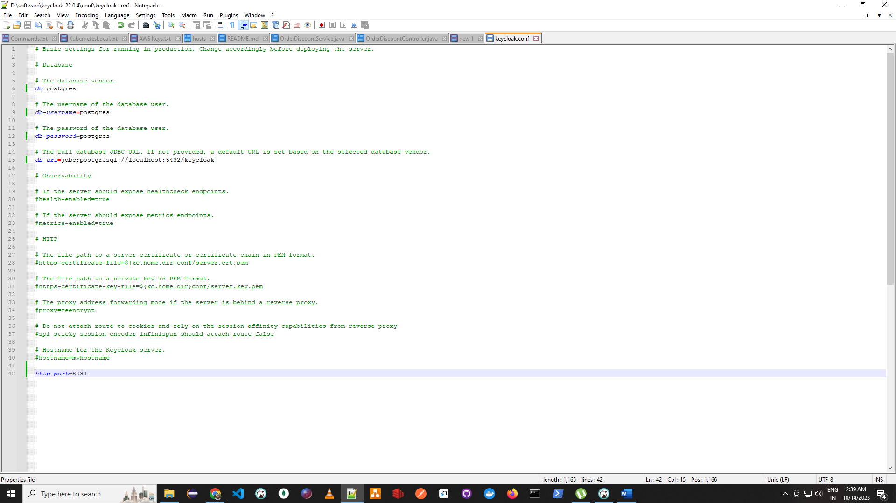

Start The Key Cloak Server

keycloak-22.0.4\bin>kc start-dev

Access Server using <http://localhost:8081>

Enter any user name and password [admin/admin/admin] and click create

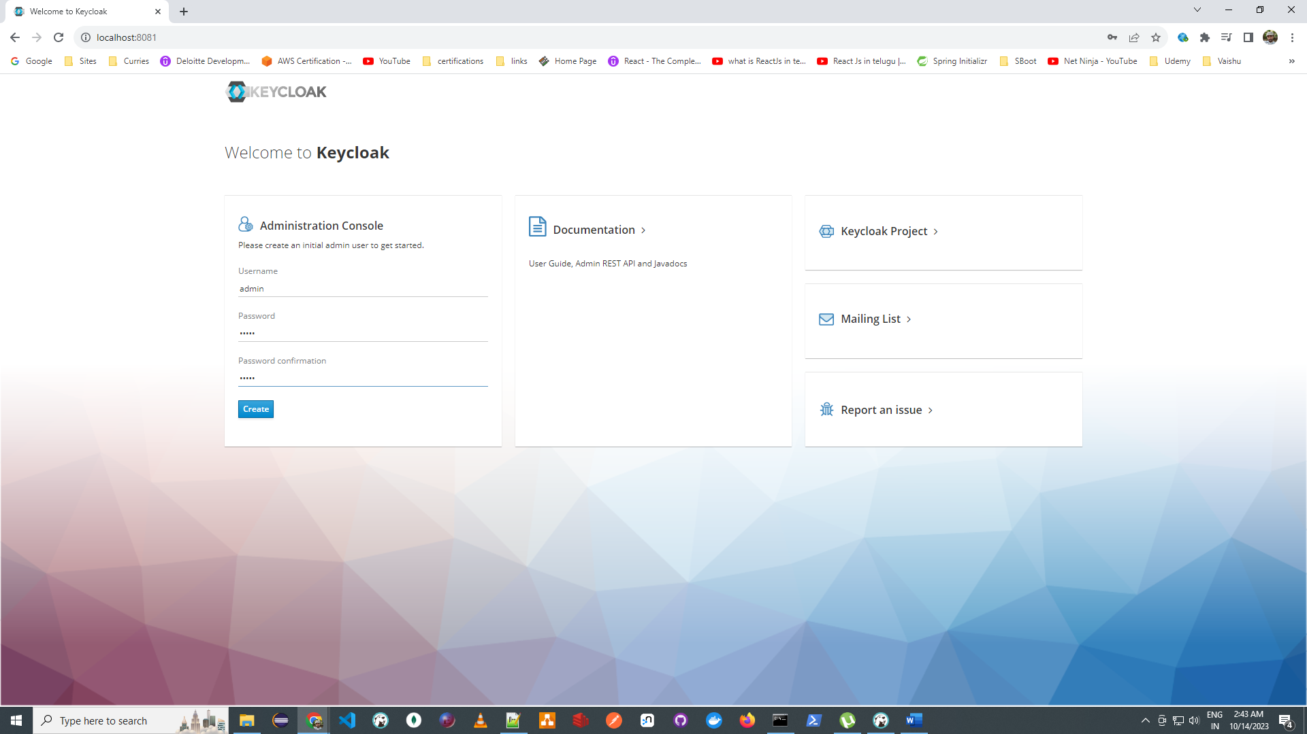

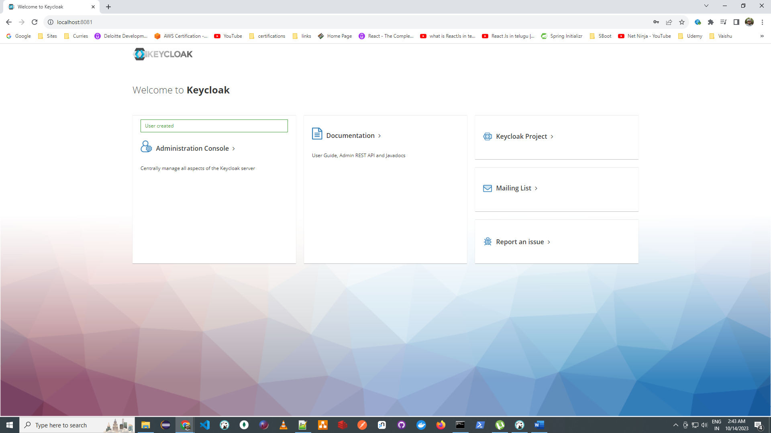

Click on Administration Console

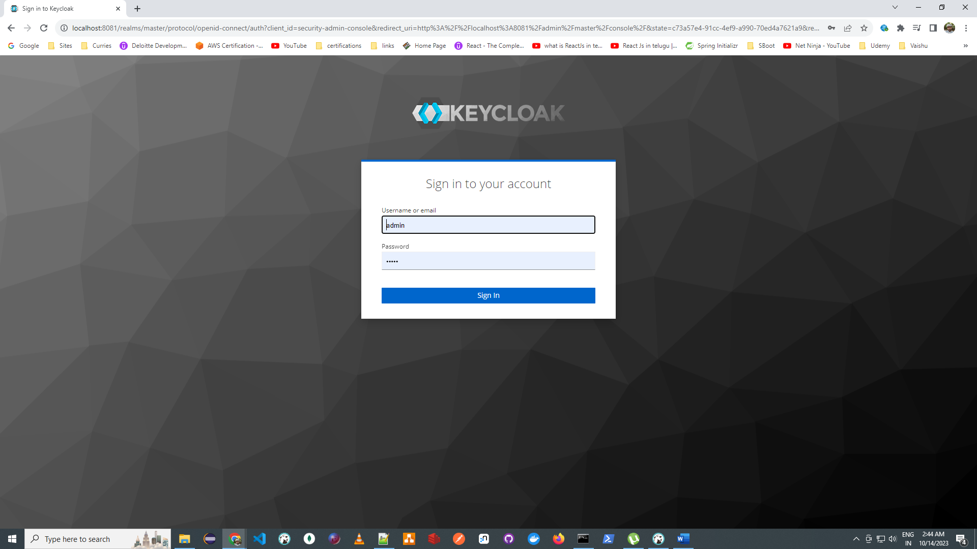

Enter admin/admin as created above and click on sign in

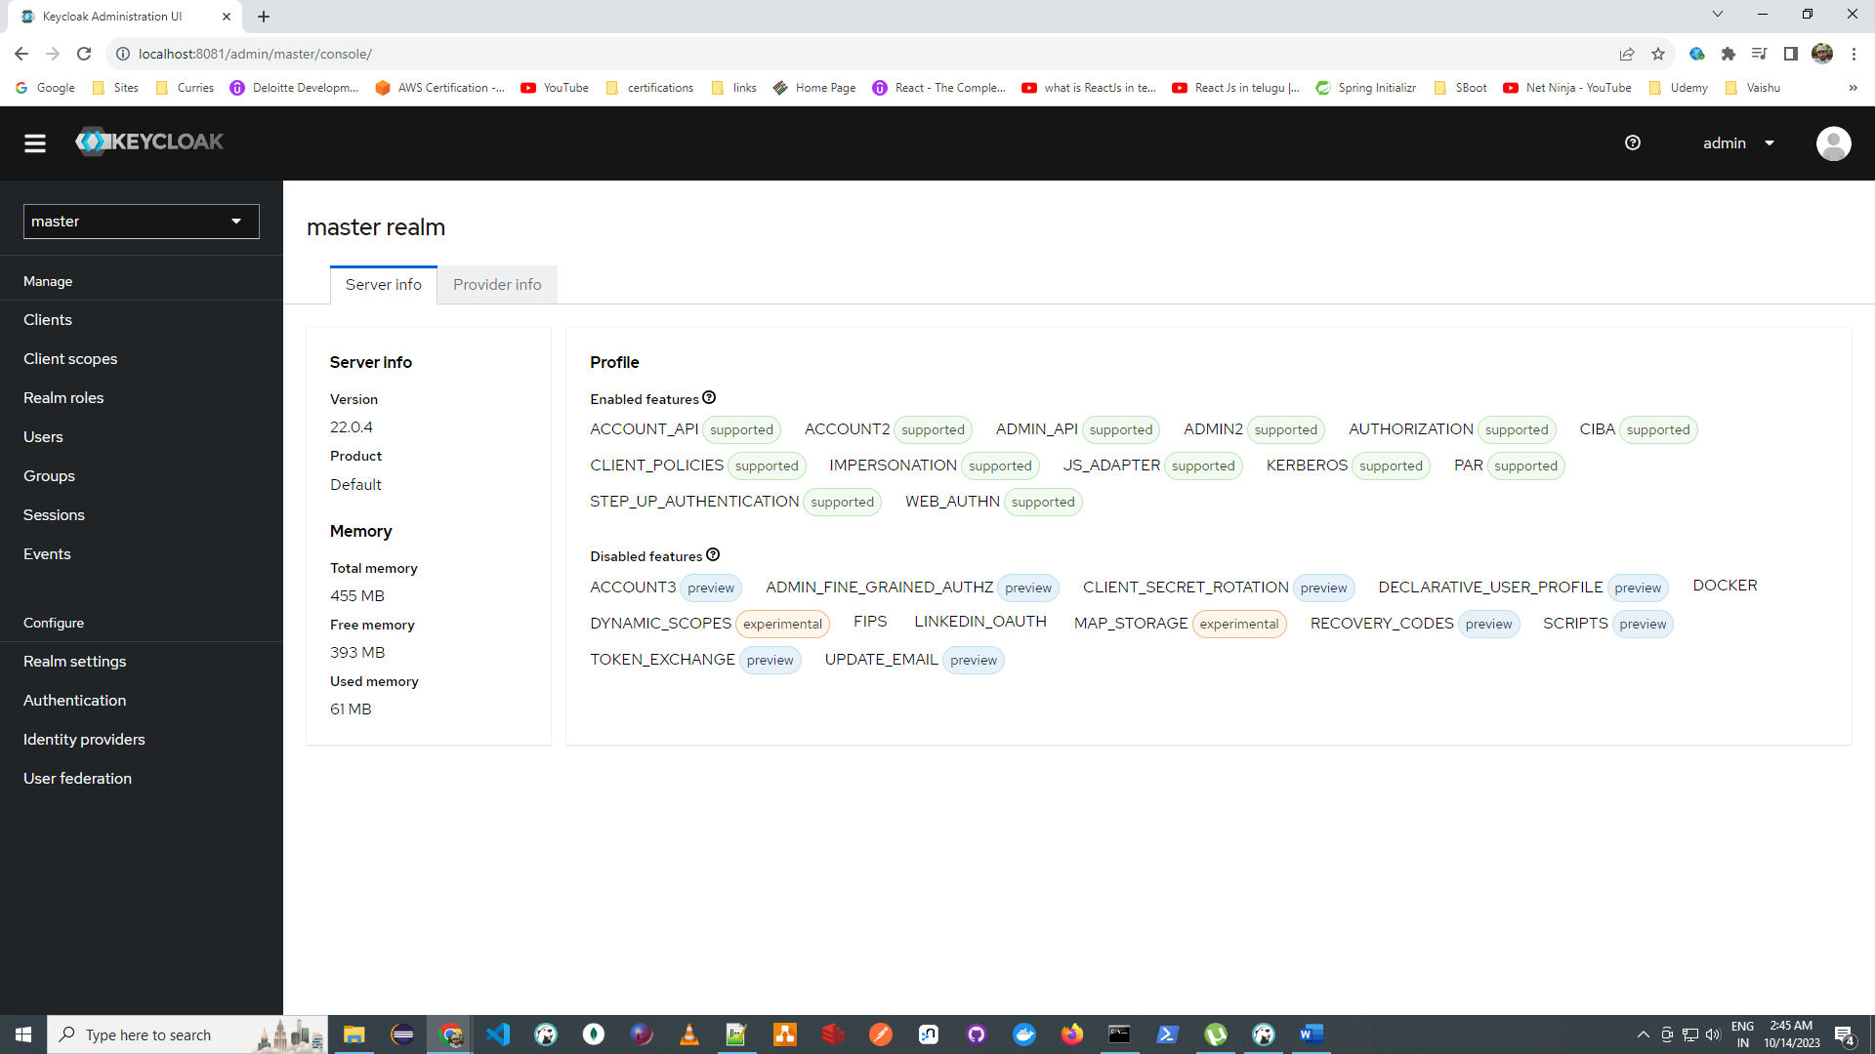

Configure Key Cloak

Click on Create Realm

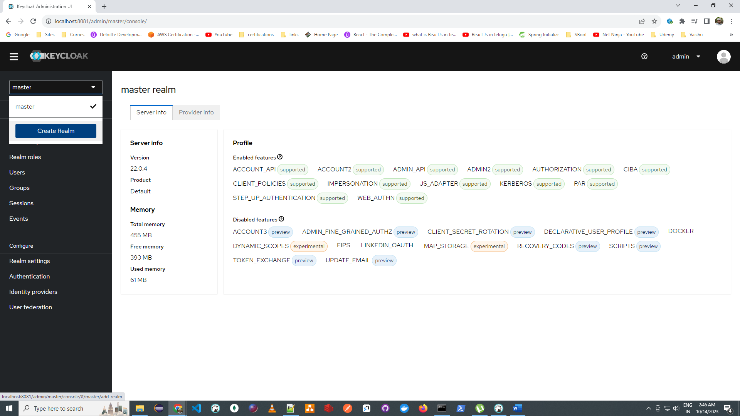

Enter realm name and click on create

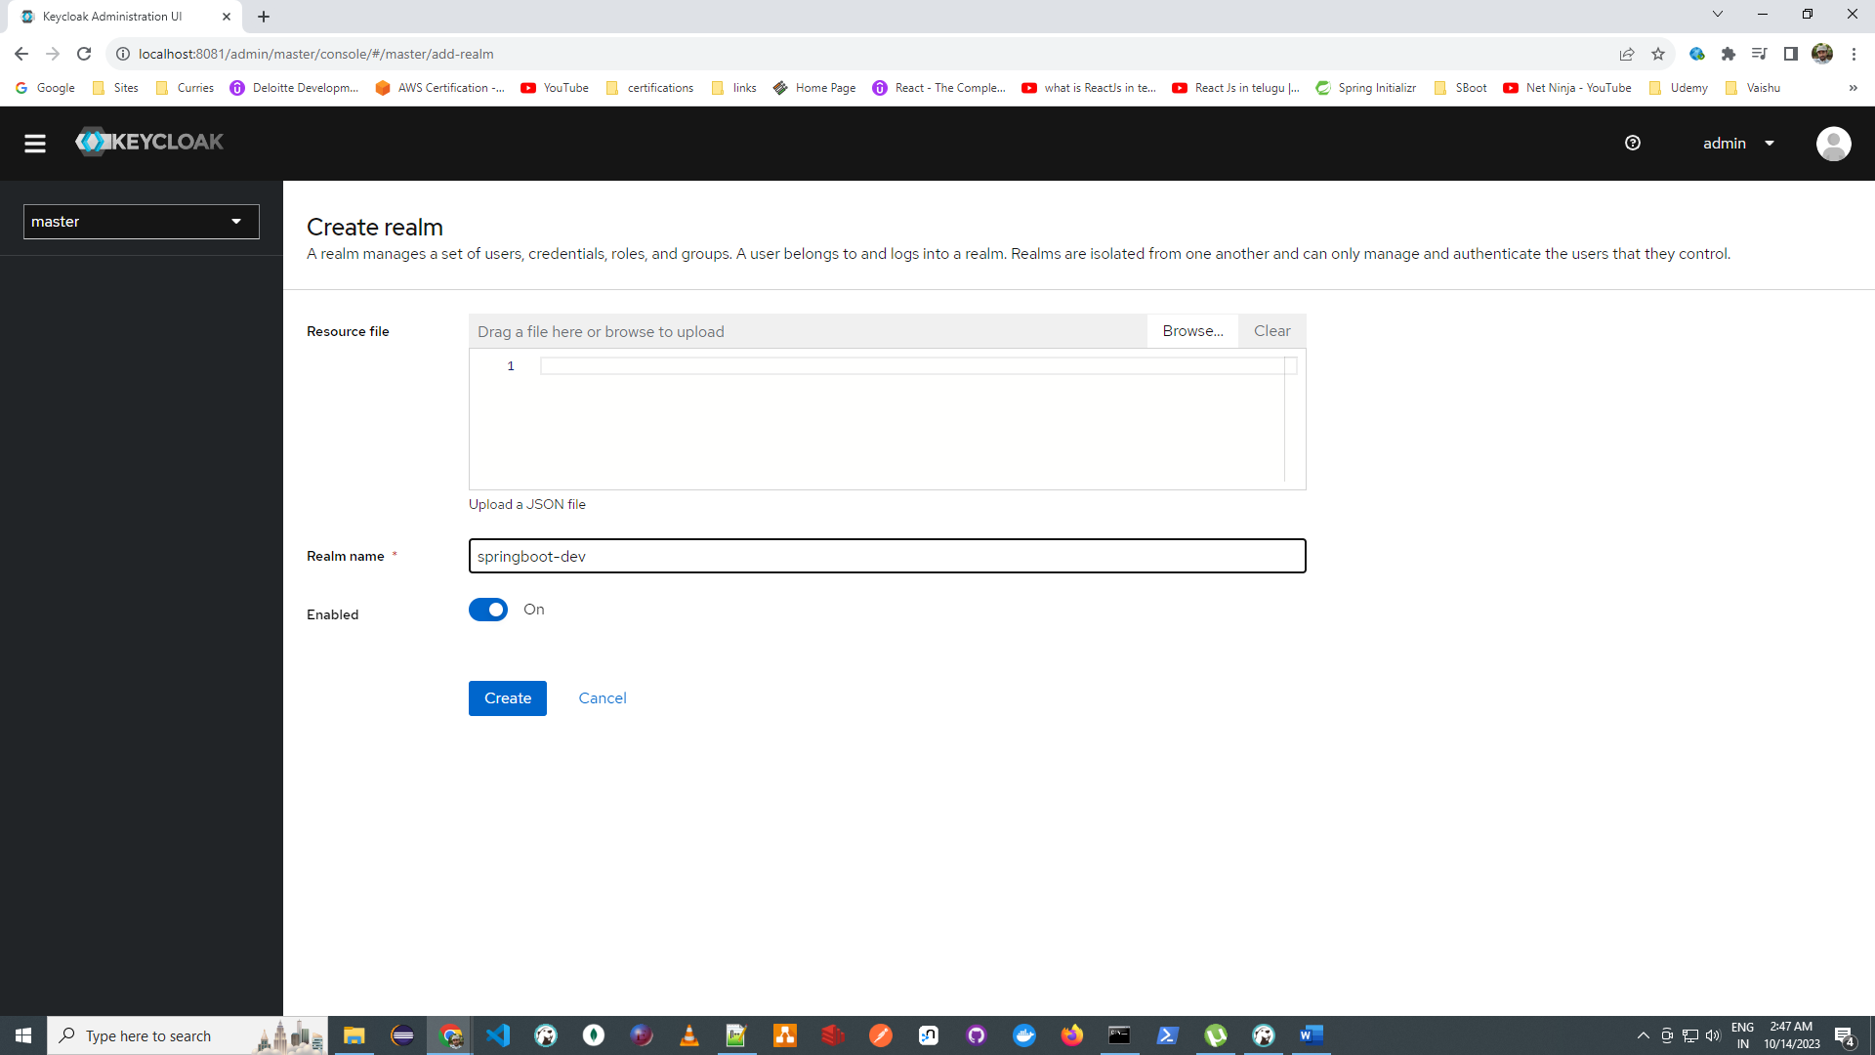

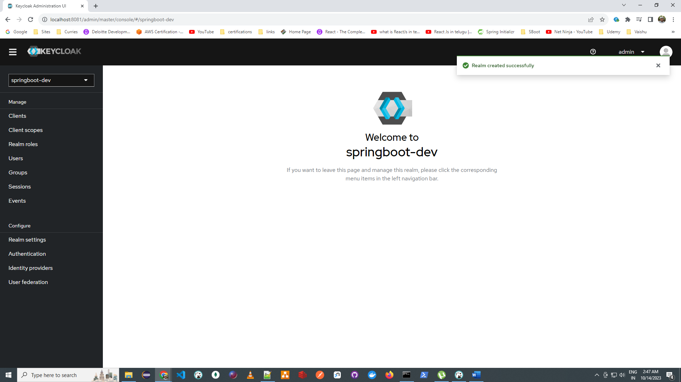

Click on Client [Ex: Realm is like Microsoft and Clients are like Teams, Outlook etc..]

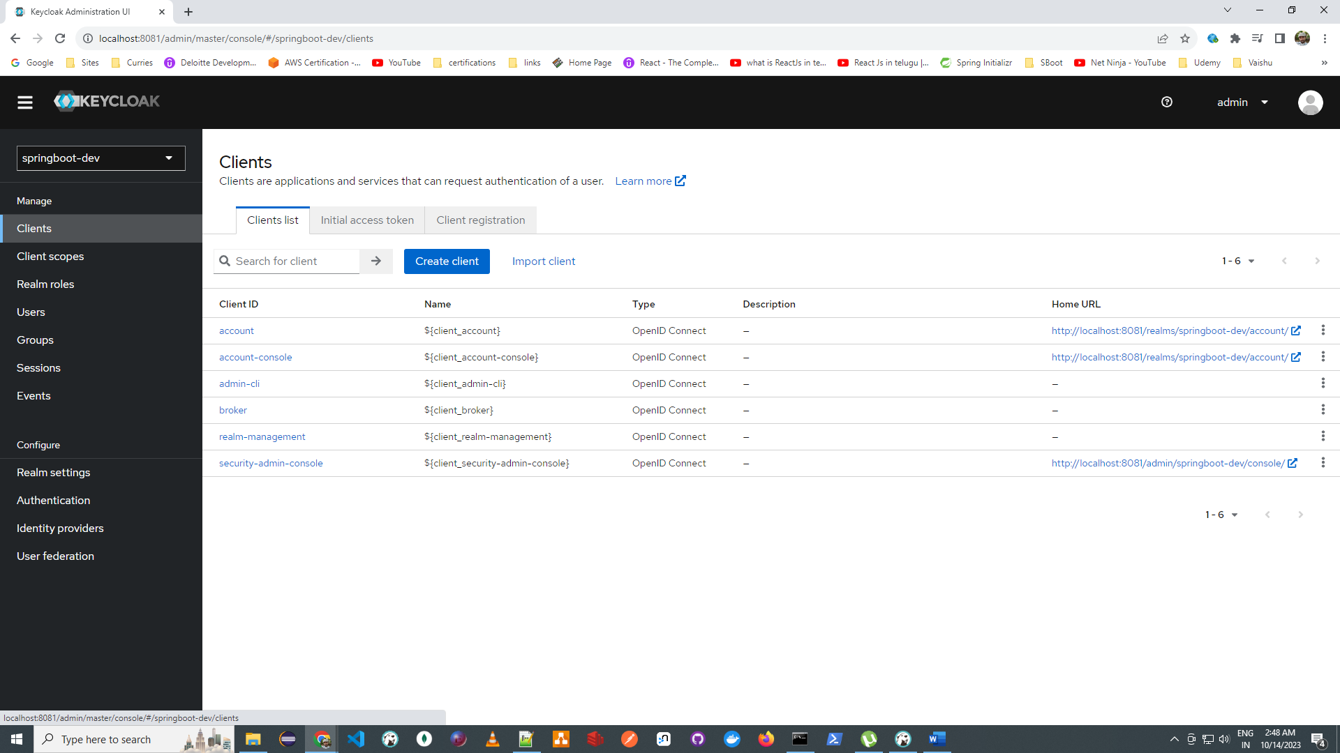

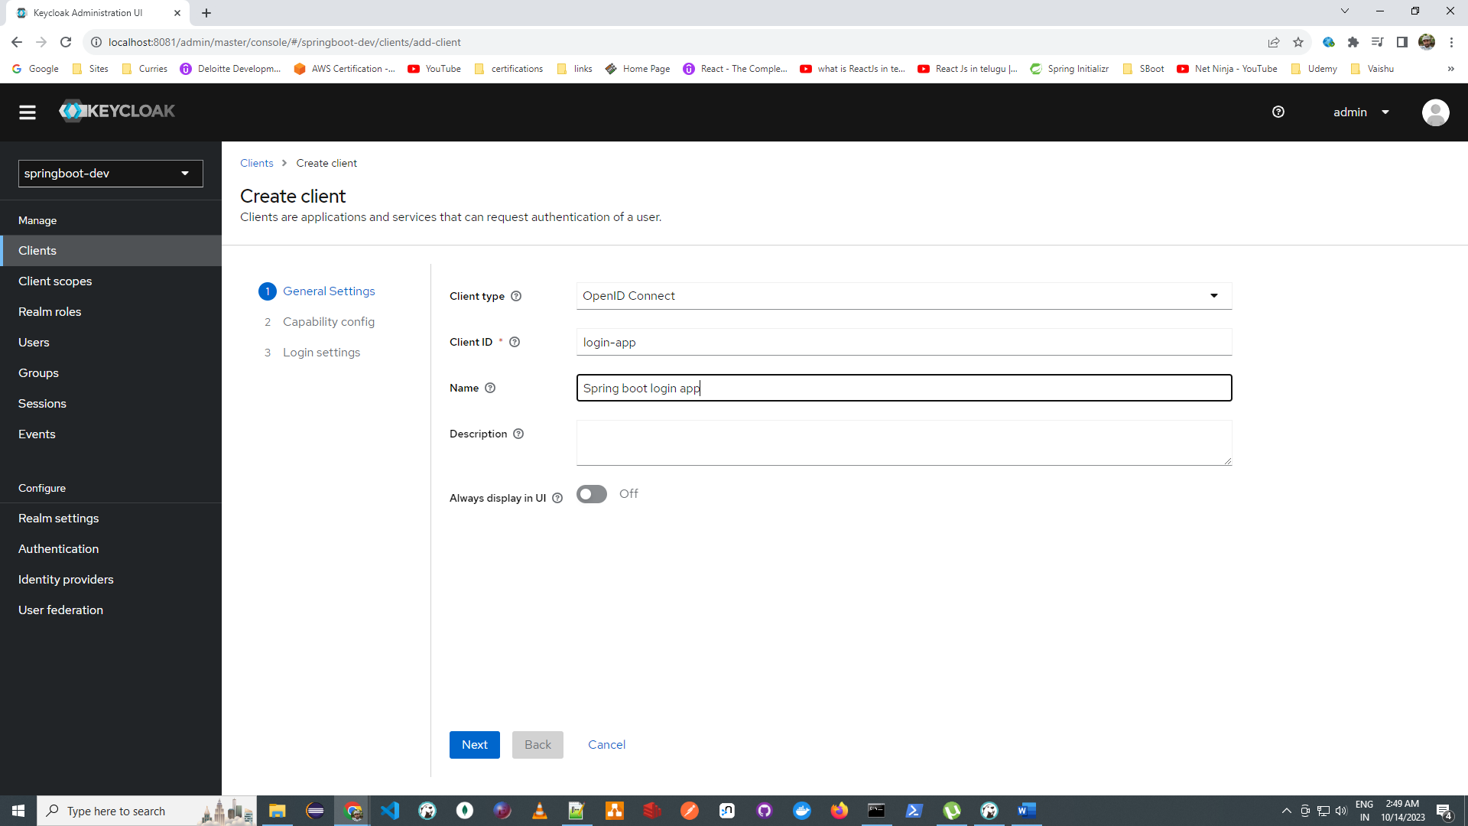

Direct is useful for REST client and enable Client Authentication

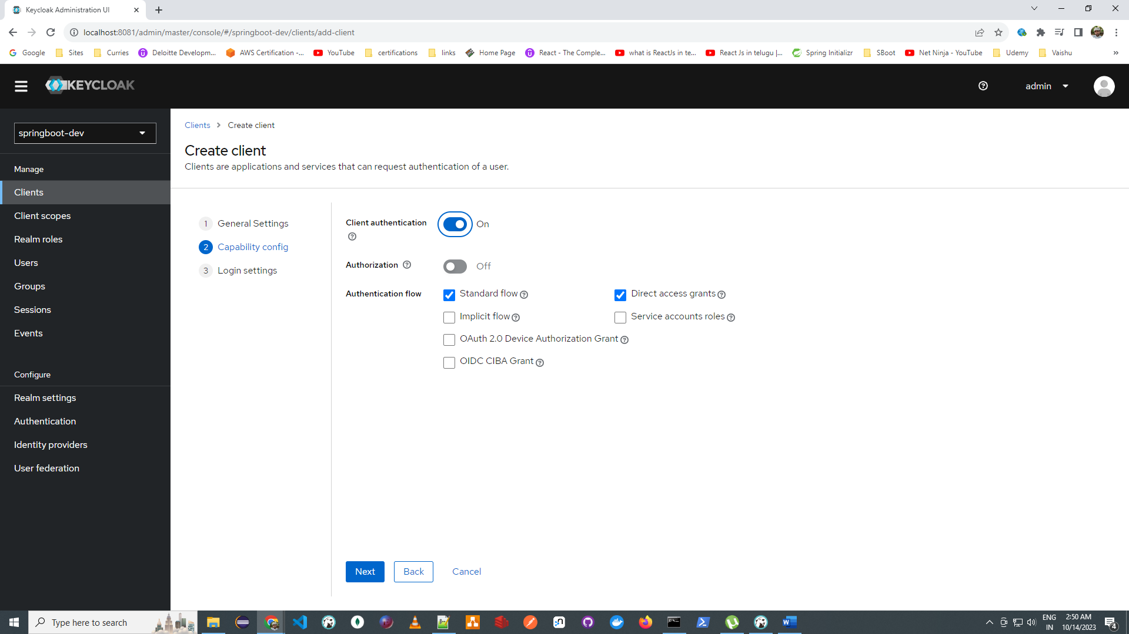

Web Origins \* to avoid CORS issues and click Save

Valid Redirect URI is where spring boot app is running

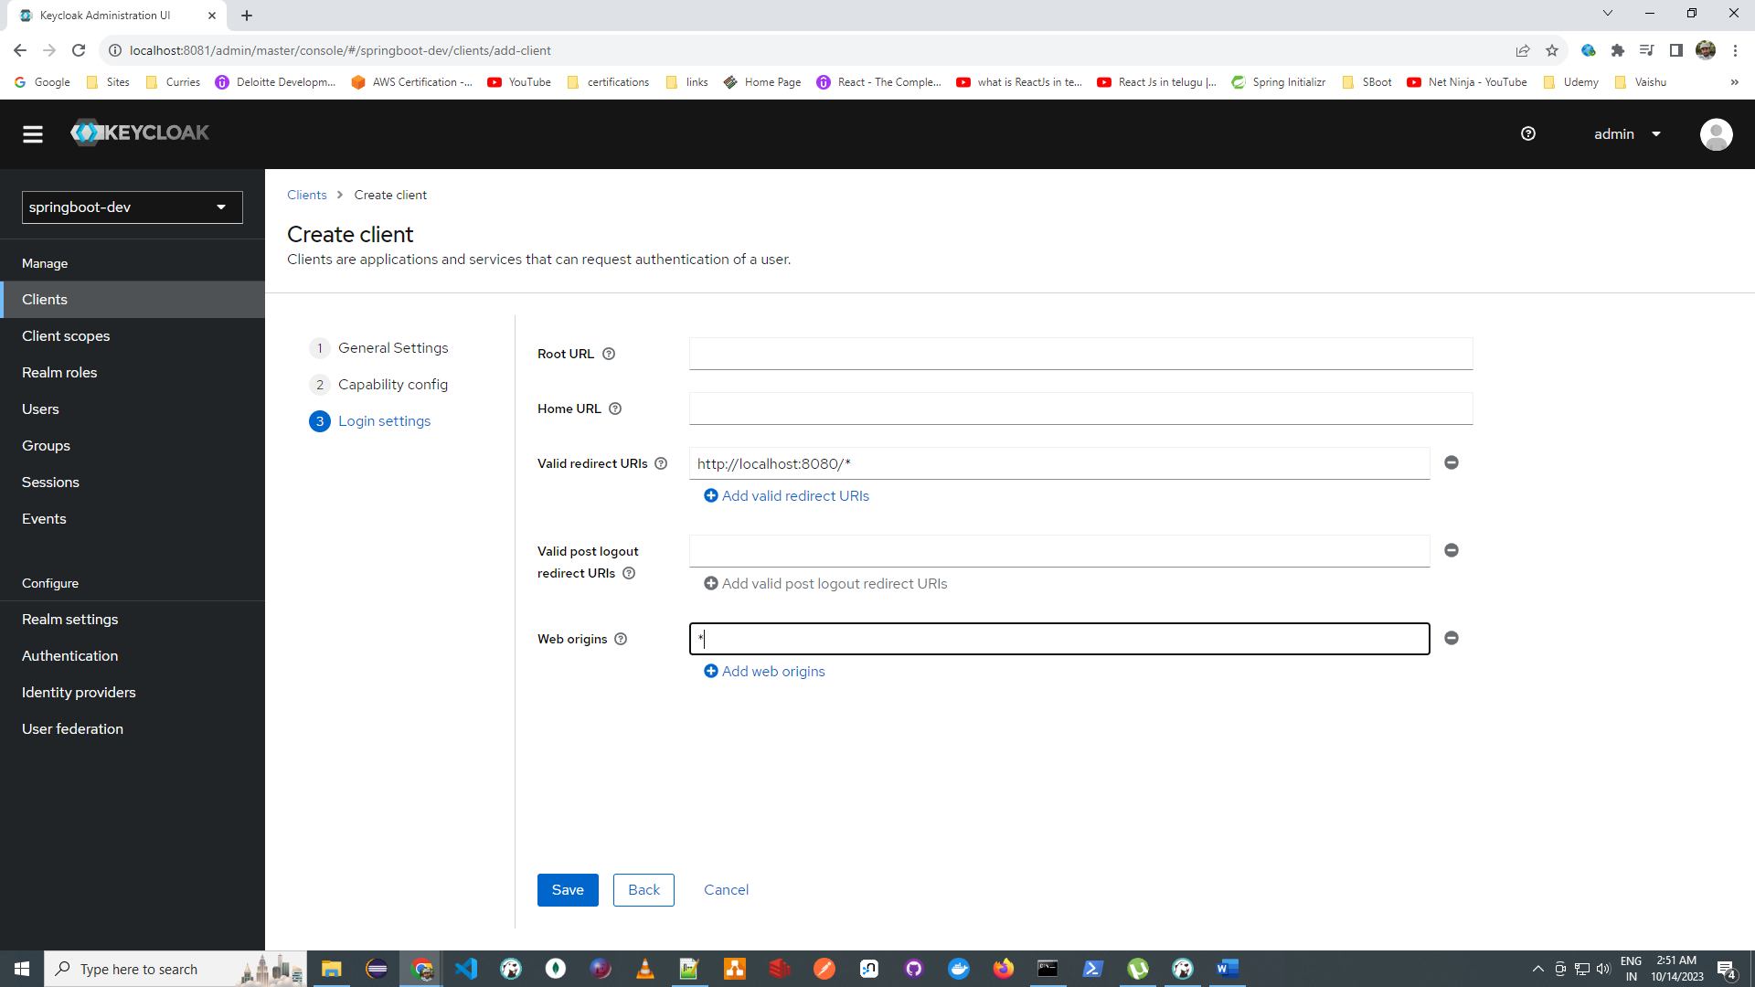

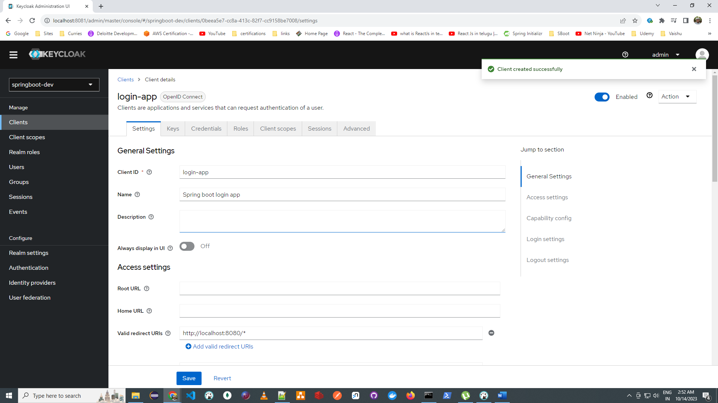

Create A User

Click on Users

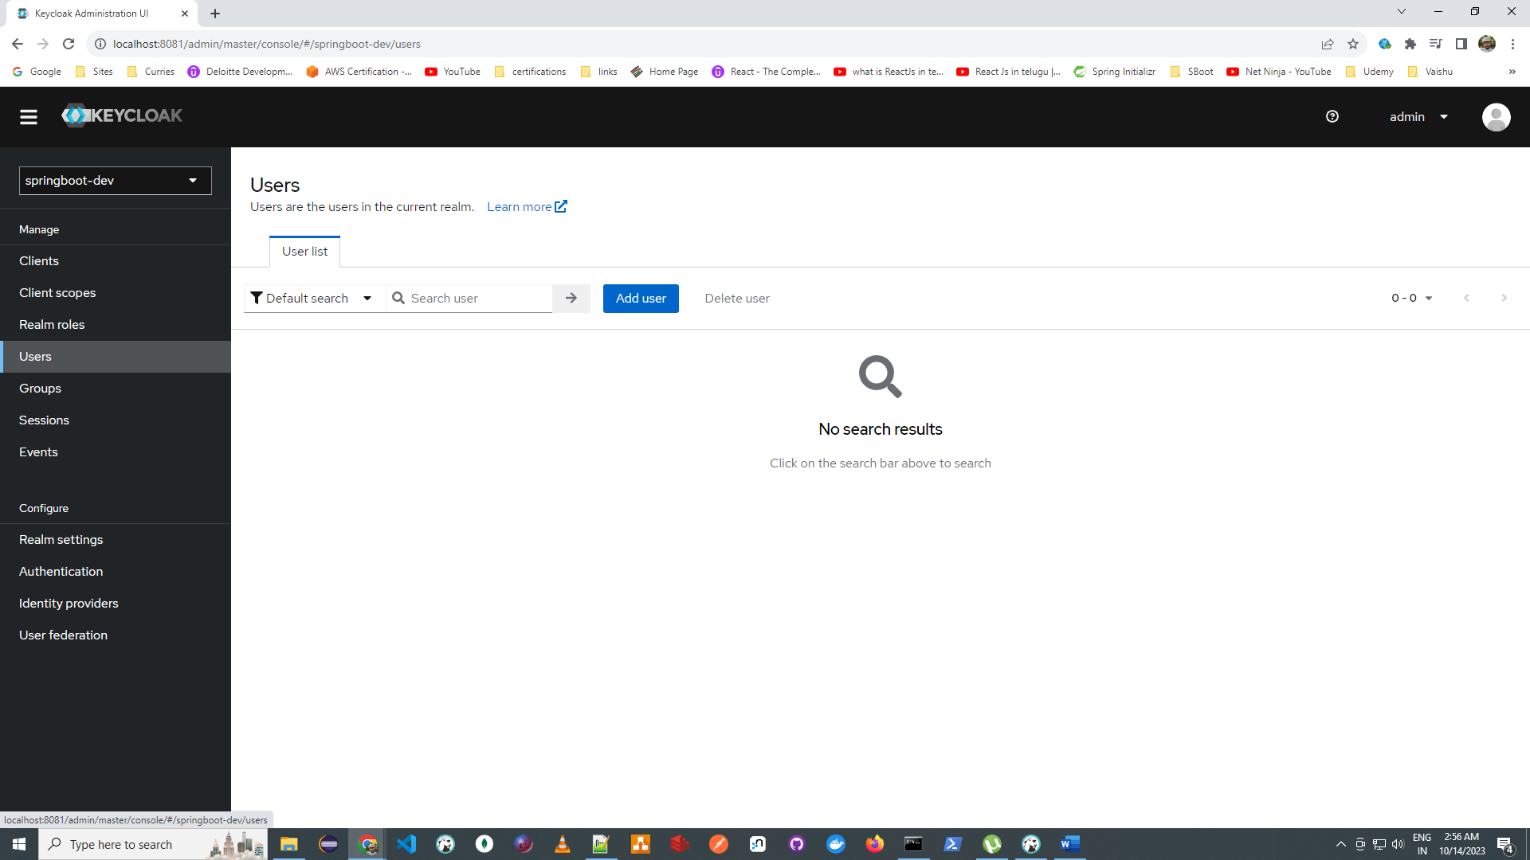

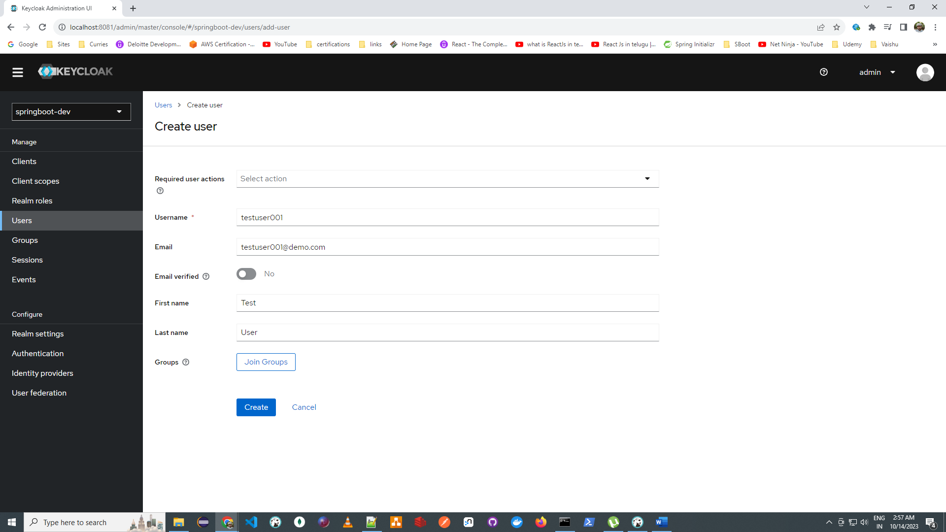

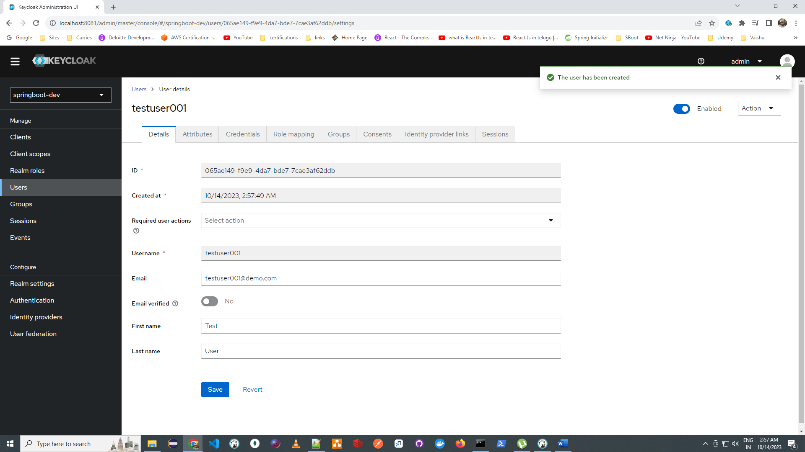

Set password

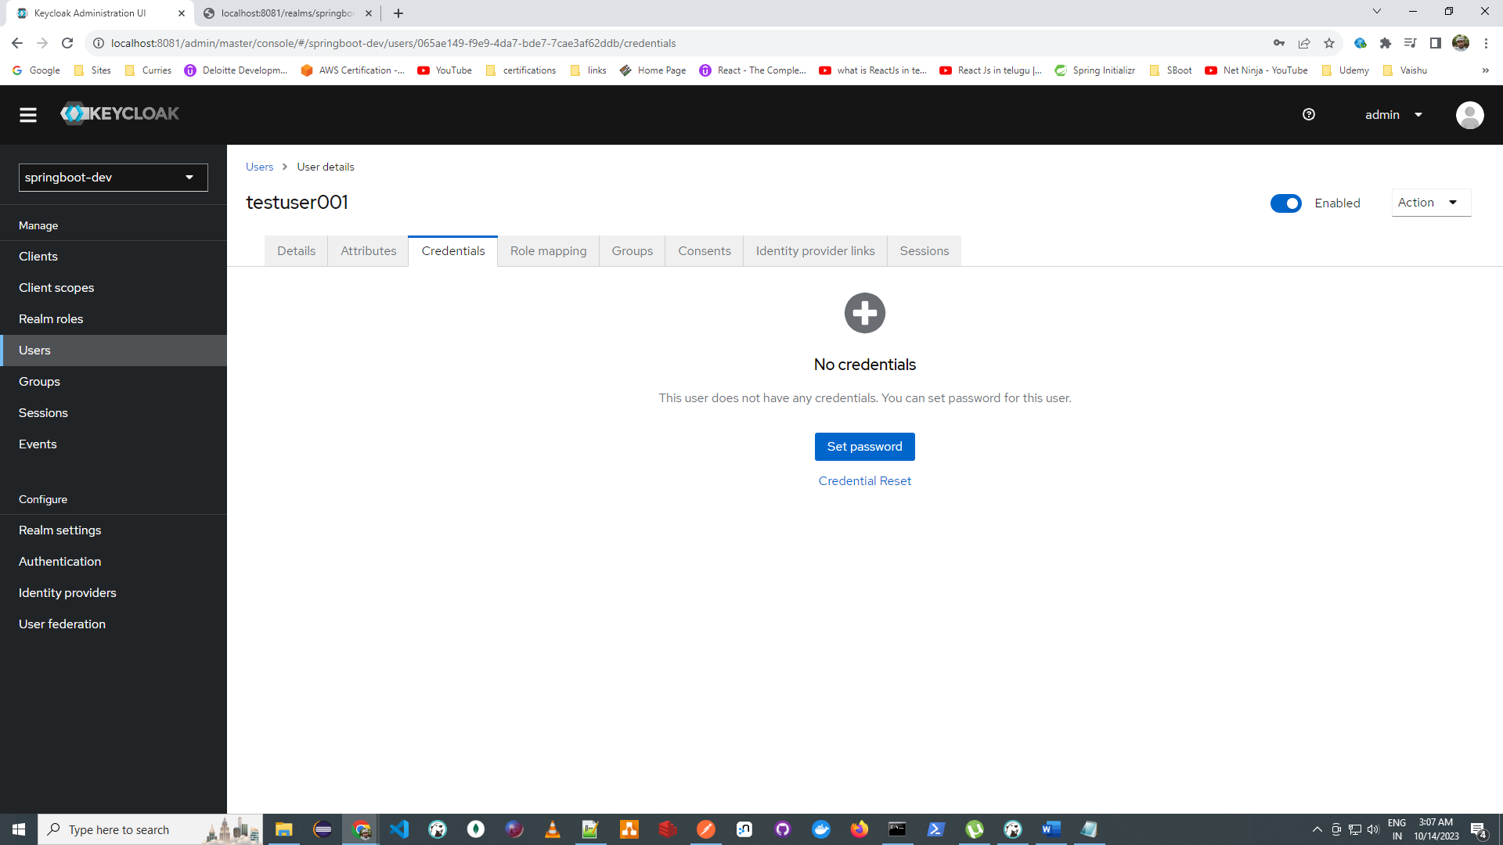

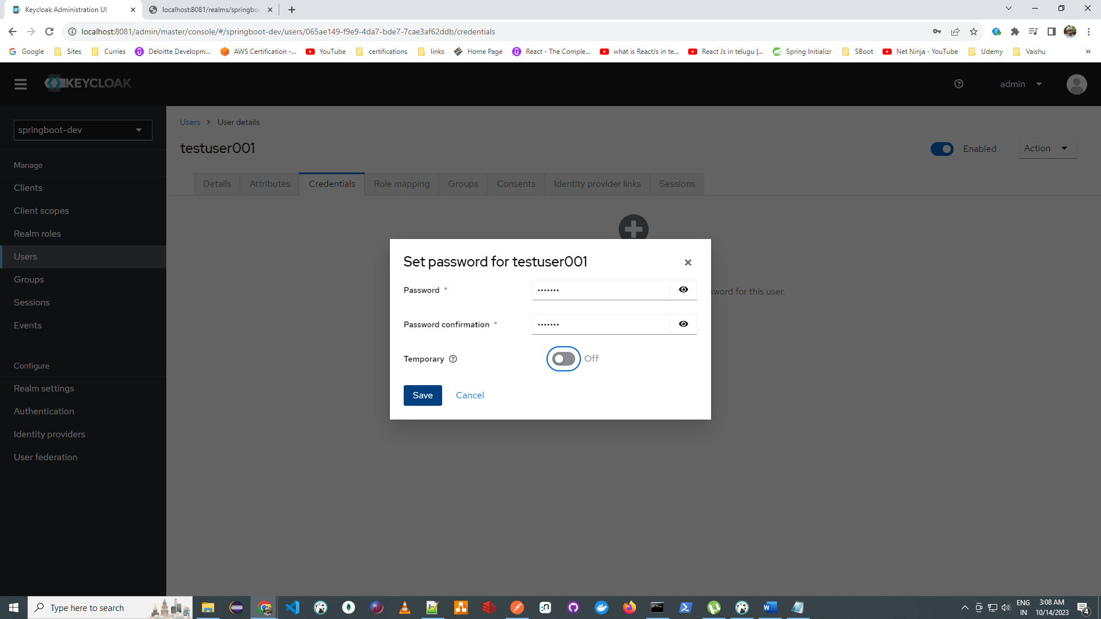

By Default : default role will be assigned

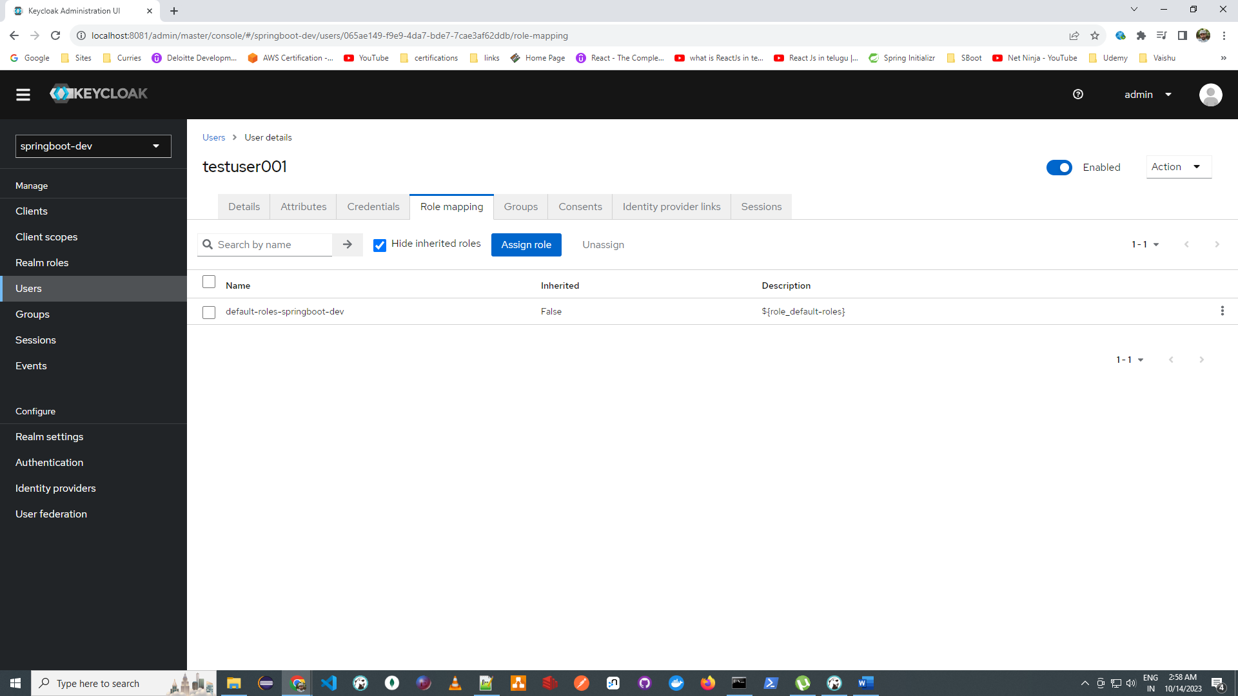

Direct Grant Authentication Flow

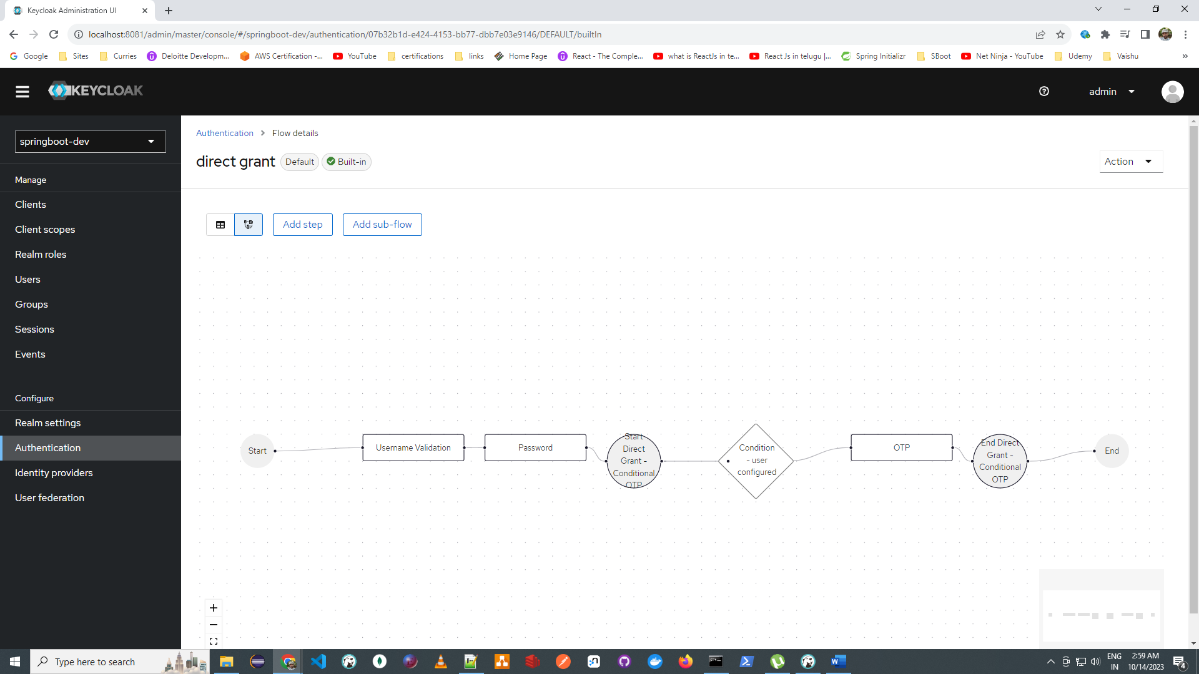

Go to <http://localhost:8081/realms/springboot-dev/.well-known/openid-configuration>

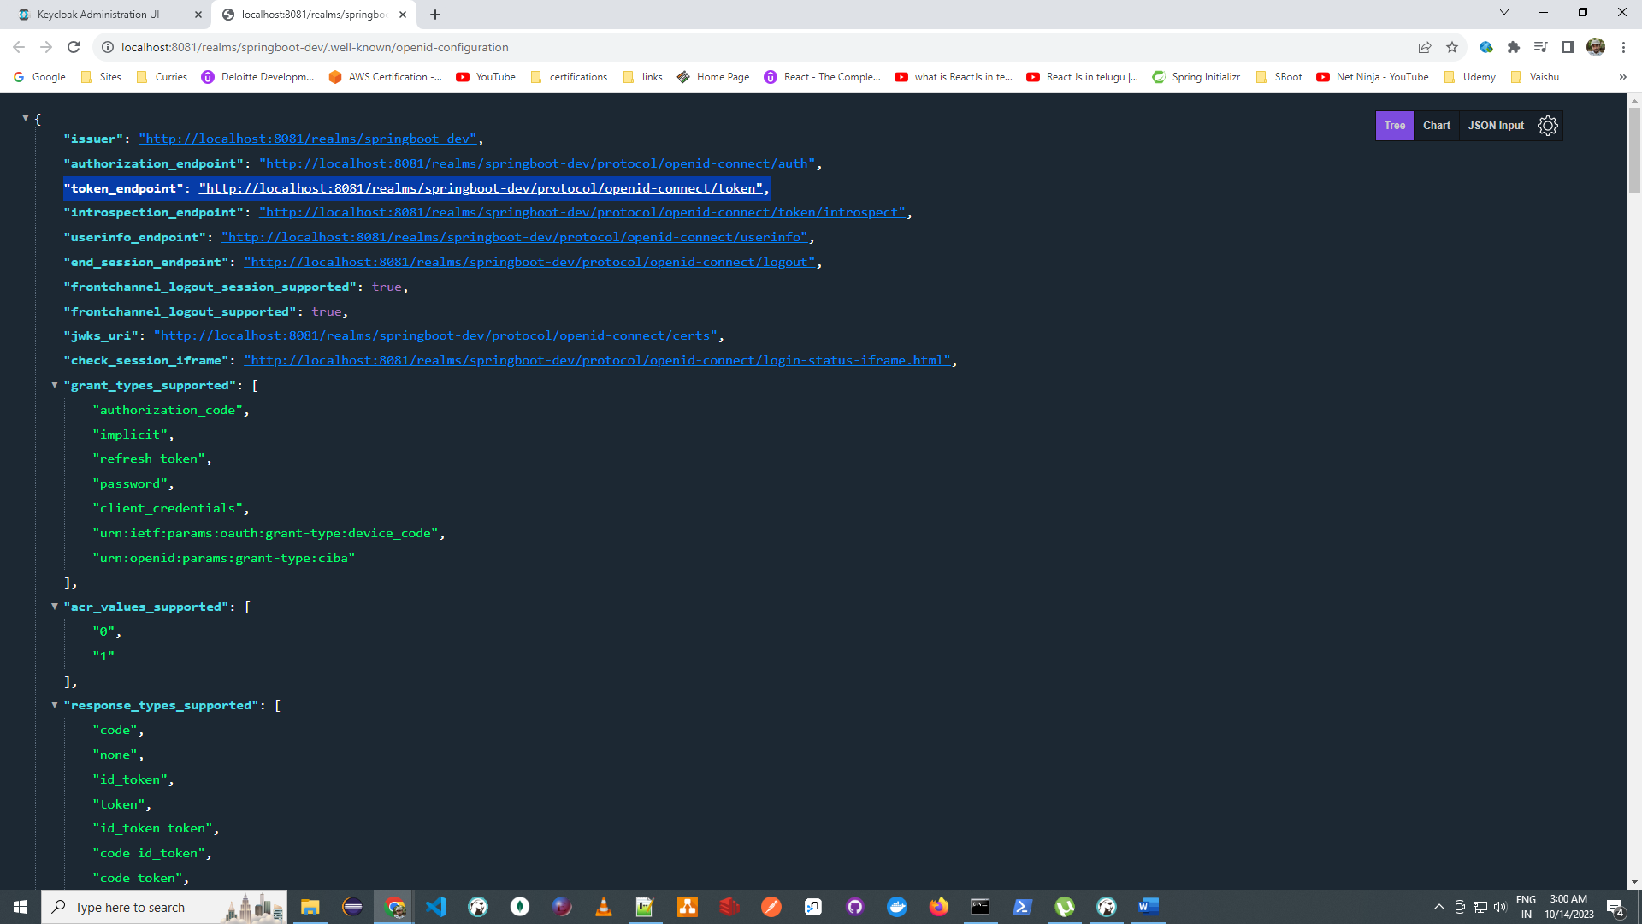

Copy <http://localhost:8081/realms/springboot-dev/protocol/openid-connect/token>

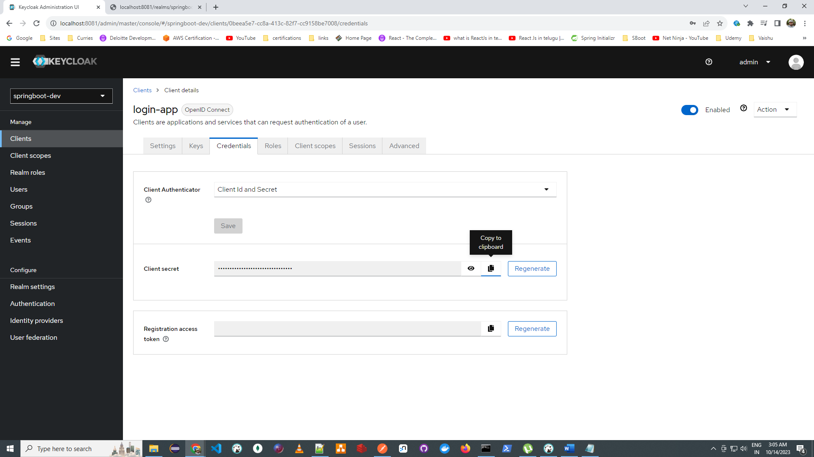

Open Postman and enter details, refer above screen for reference

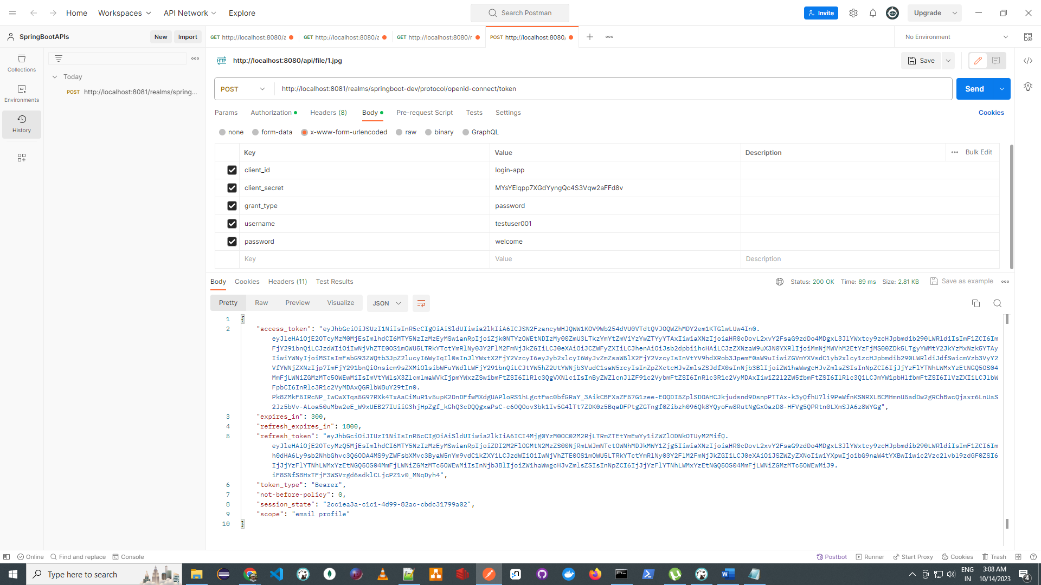

Check Session for the user

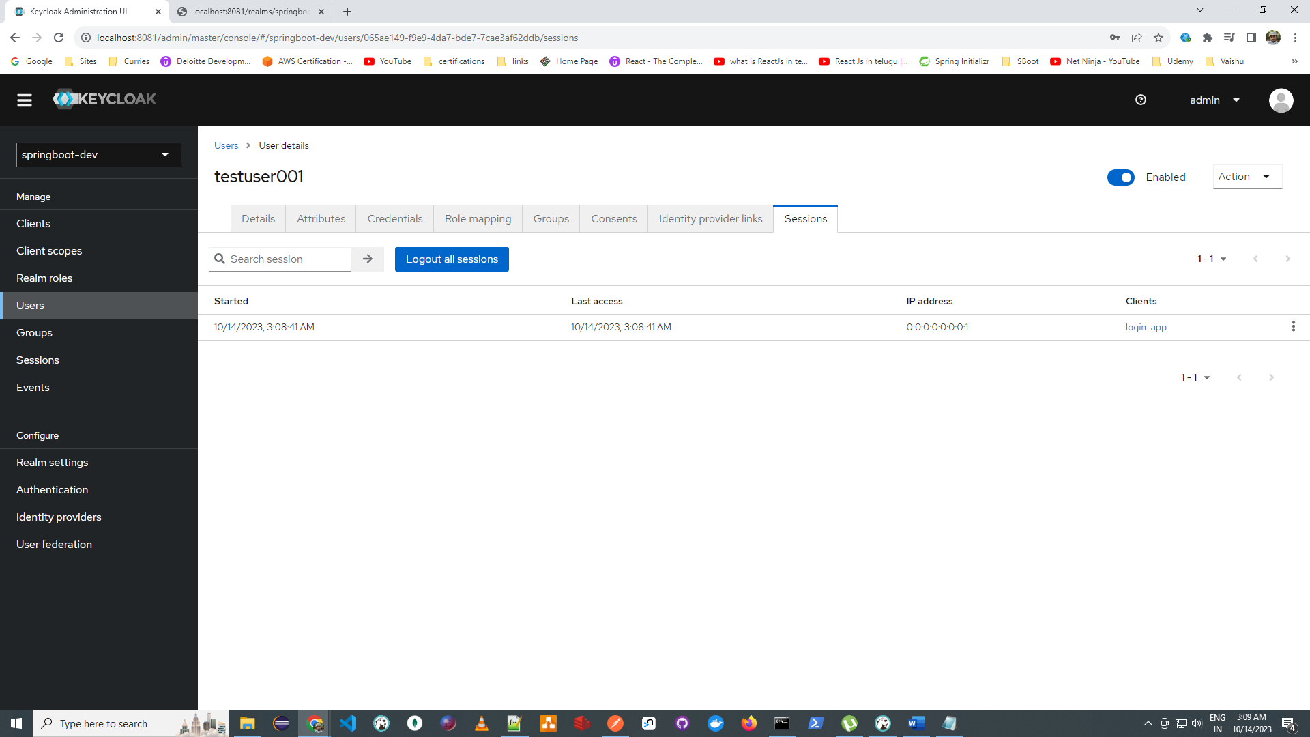

Introspect the token

<http://localhost:8081/realms/springboot-dev/protocol/openid-connect/token/introspect>

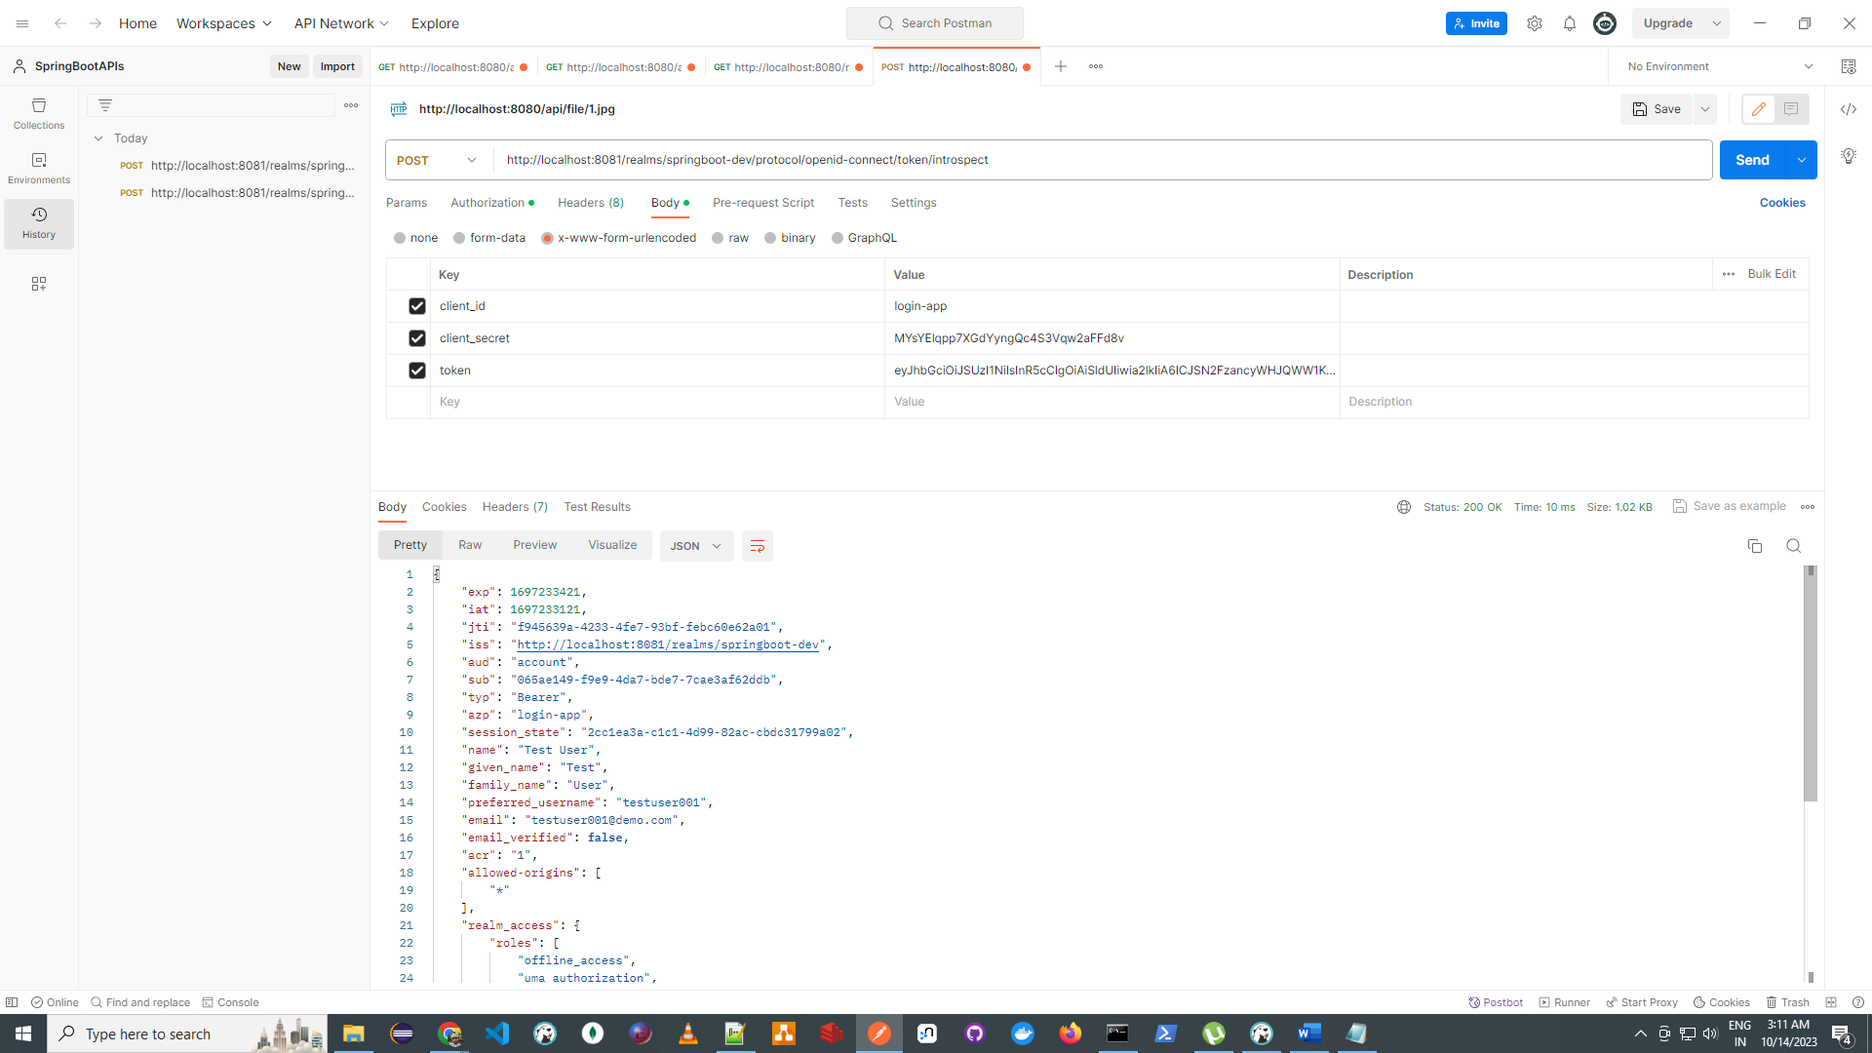

Open <http://jwt.io> and paste token

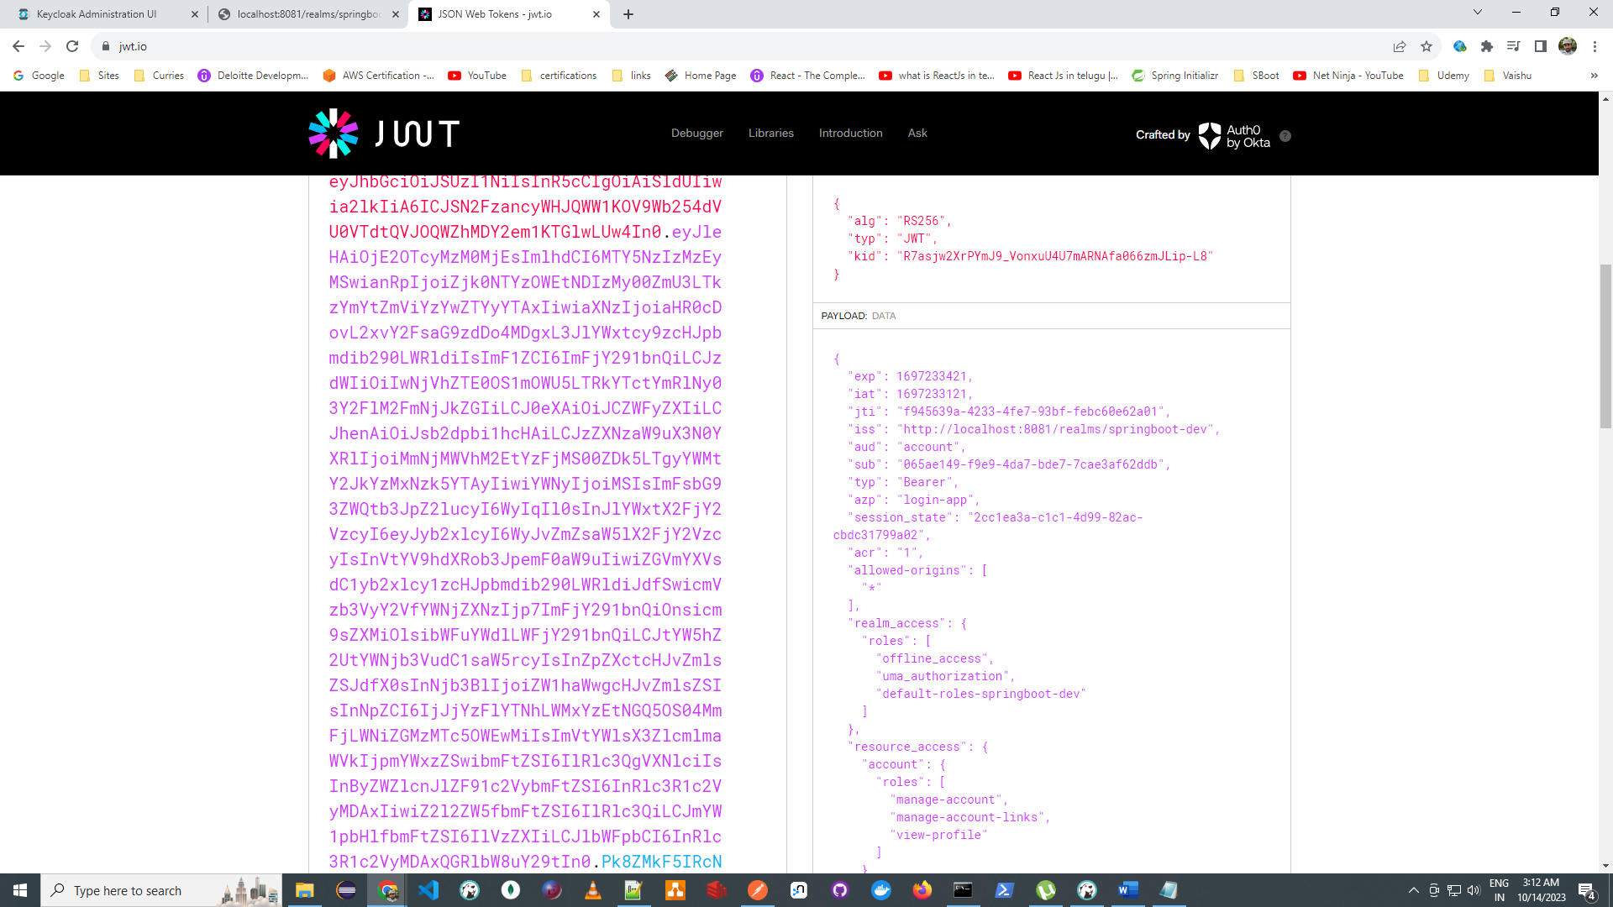

Logout the token

<http://localhost:8081/realms/springboot-dev/protocol/openid-connect/logout>

add Refresh token

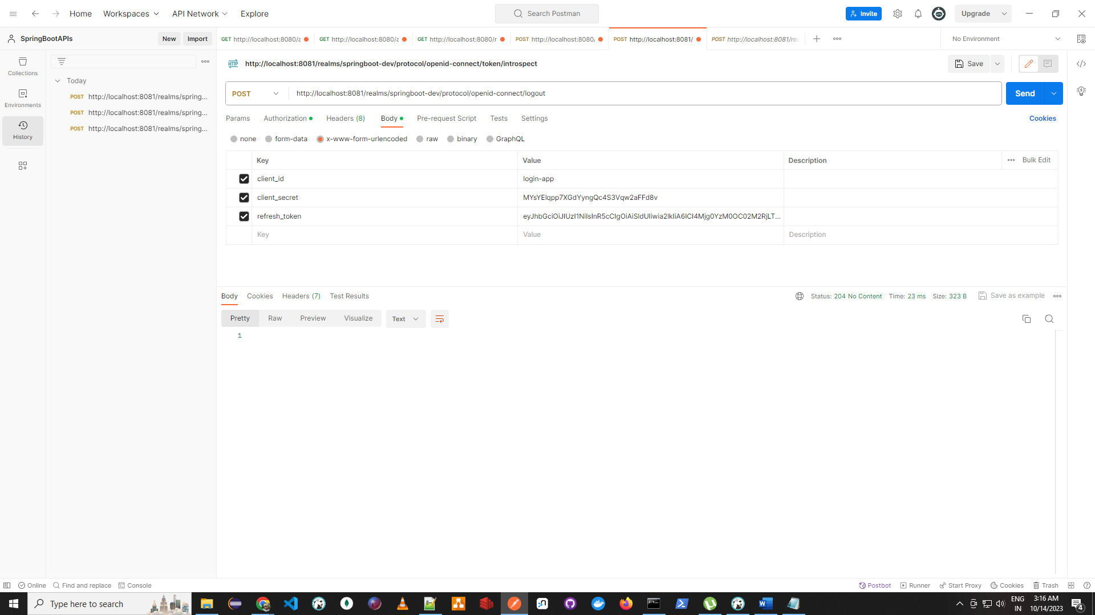

Now introspect the token

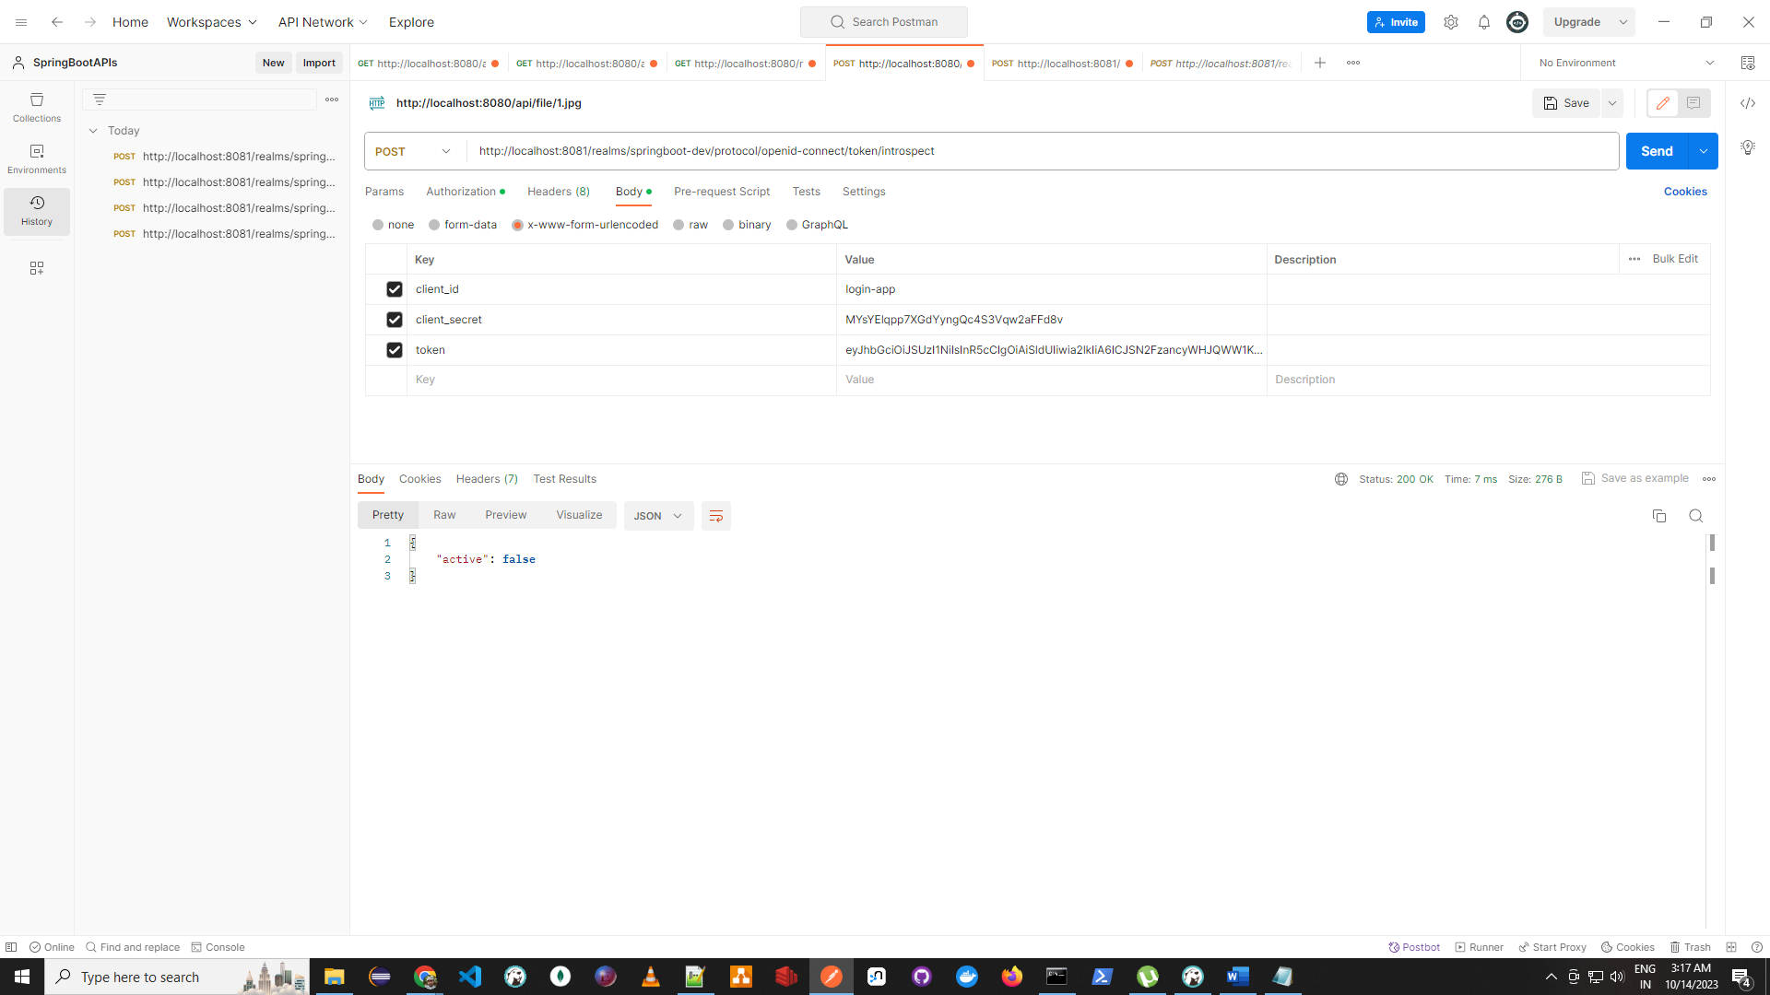

Check the session

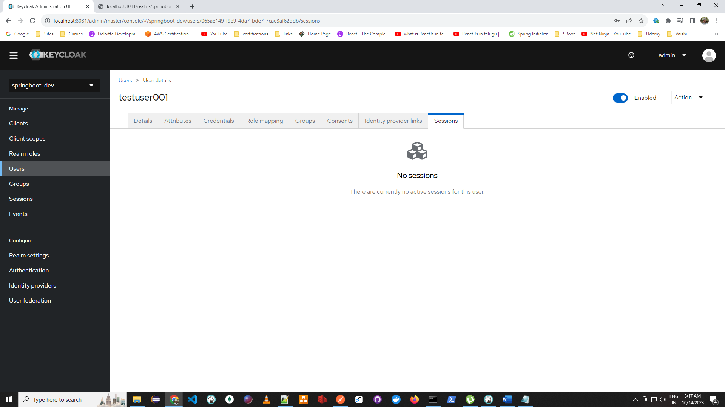

Refresh the token : Example : Access token expired but user not logged how to get new token

Geth the new token and assume access token expire, use refresh token to get new access token

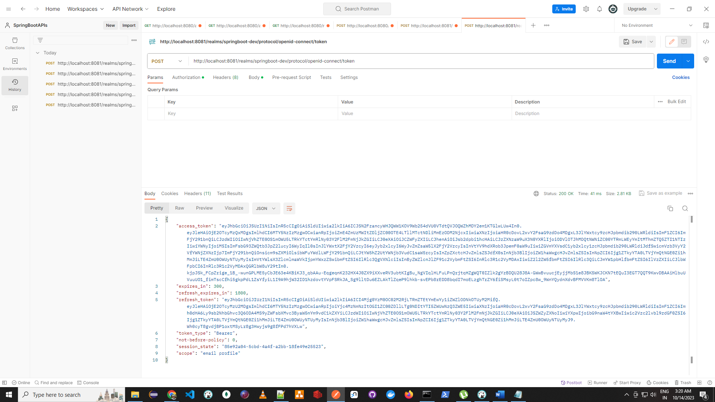

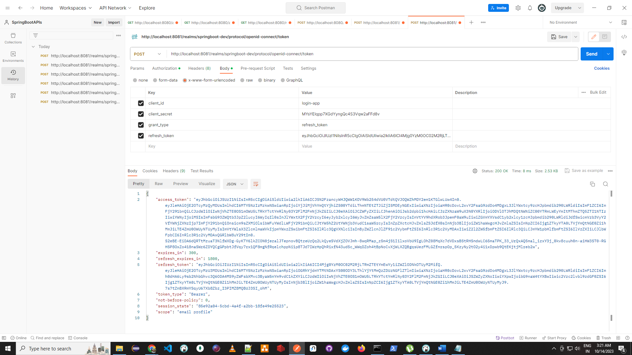

Use case [future development]

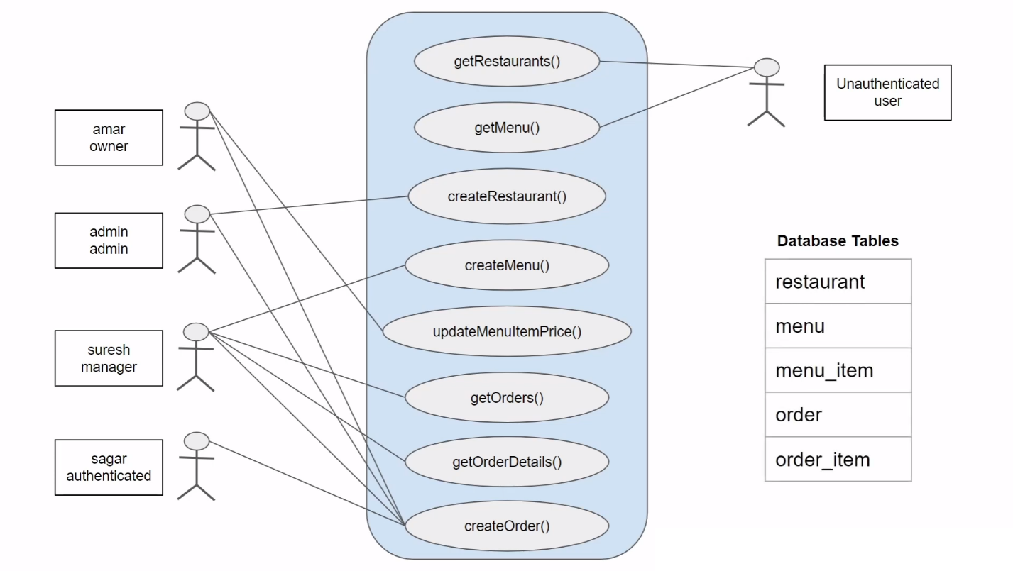

Token diagram

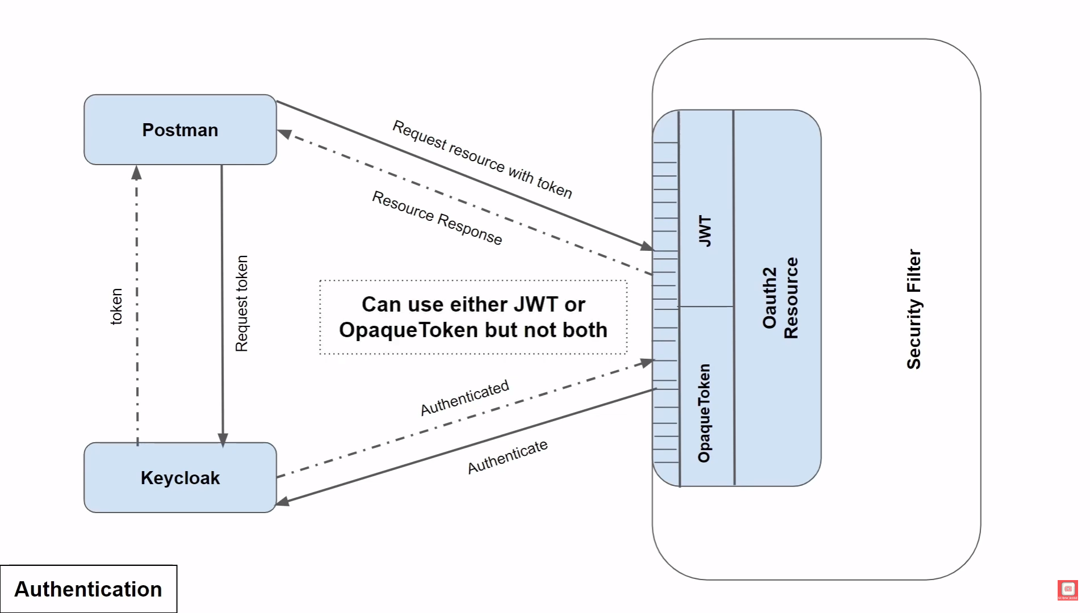

Timestamp validator

